Cases: always

1. 97
2. 195
3. 295
4. 395
5. 495
6. 595

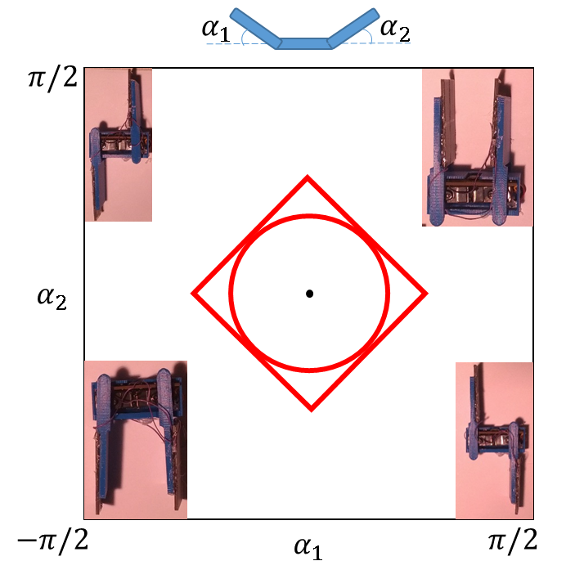

Stress on, updated 10-14-15

|  |  |  |
| --- | --- | --- |
| RangeType (index in program) | Config ()/Gait | Frequency |
| 0 | (0,0) | X<96 |
| 1 (stress move) | (30,30),(-30,-30) | N/A |
| 2 | (30,30) | 96-154 |
| 3 | (90,90) | 155-200 |
| 4 | (-90,-90) | 200-254 |
| 5 | (90,-90) | 254-302 |
| 6 | Circle gait | 302-355 |
| 7 | Diamond gait | 355-400 |